You are Welcome to join us for the 34th
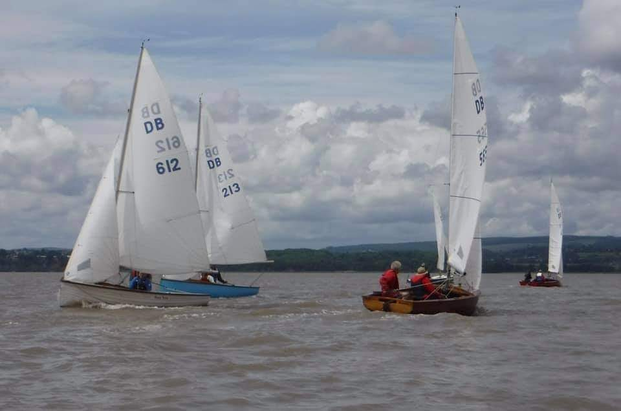

Thornbury db open 2021
  - 17th and 18th July

SATURDAY 11.55AM - Two races either side of the tide, both to count. SUNDAY 11.55AM - Up river cruise to suitable inlet, picnic and sail back with out going tide.
- £10 per boat for one day, £15 for the weekend, pay on the day.
- Changing facilities including showers.
- Morning breakfast in the boatshed and licens clubhouse bar.
- Hog roast evening meal (pre-booked) and live entertainment.
- Free camp grounds, camper vans welcome.
Dayboaters at TSC look forward to giving you a warm welcome!
For further information see TSC website, YWDB website,
or contact Dave Allen on davemallen@hotmail.co.uk

