**

**

|  |  |
| --- | --- |
|  | **GP14 AND YACHTING WORLD DAYBOAT OPEN WEEKEND 2021**  **Saturday 14th August and Sunday 15th August 2021**  **Organising Authority - Poole Yacht Club**  **Poole Harbour, UK**  **Notice of Race (NOR)** |
|  | **The Event will be held at Poole Yacht Club, and both fleets (GP14 and YWDB) will sail all races in Poole Harbour using the same committee boat and start lines, but separate starts. The event will be split into two days: Saturday being up to 2 races round the Harbour Islands and Sunday will be up to four races in Poole Harbour Top Triangle.** |
|  | The notation ‘[NP]’ in a rule means that a boat may not protest another boat for breaking that rule. This changes RRS 60.1(a). |
| **1** | **RULES** |
| **1.1** | The event is governed by the rules as defined in *The Racing Rules of Sailing.* |
| **1.2** | The Rules of the GP14 Class Association, available at <https://www.gp14.org/> applies.  The Rules of the YWDB Class Association, available at <https://www.ywdb.co.uk/> applies.  This Notice of Race, available at [*https://www.pooleyc.co.uk/*](https://www.pooleyc.co.uk/)applies.  The Sailing Instructions for this event, available at [*https://www.pooleyc.co.uk/*](https://www.pooleyc.co.uk/)applies.  Poole Harbour Sail Racing Procedures (formerly Yacht Racing Criteria), available at <https://www.phc.co.uk/wp-content/uploads/2020/08/Poole-Harbour-Sail-Racing-Procedures-V.8-Aug-2020.pdf>applies. |
| **1.3** | **[NP] COVID Statement** By taking part in any of the events covered by this notice of race, each competitor agrees and acknowledges that they are responsible for complying with any regulations in force from time to time in respect of COVID-19 and for complying with the Poole Yacht Club COVID-19 procedures. Competitors and support persons shall comply with any reasonable request from an event official. Failure to comply may be misconduct. Reasonable actions by event officials to implement COVID-19 guidance, protocols or legislation, even if they later prove to have been unnecessary, are **not improper actions or omissions.** |
| **2** | **SAILING INSTRUCTIONS** |
| **2.1** | The sailing instructions will be available after 09.00 on 09.08.2021 at [*https://www.pooleyc.co.uk/*](https://www.pooleyc.co.uk/) |
| **2.2** | The Sailing Instructions and Notice of Race will not be available in hard copy. Competitors are recommended to print their own copies or refer to the copies, which will be posted on the official notice board located on the south side of The Poole Yacht Club clubhouse. |
| **3** | **COMMUNICATION** |
| **3.1** | The online official notice board is located at <https://www.pooleyc.co.uk/> |
| **3.2** | There will be a competitor briefing on the patio outside the race office on the south side of the patio at 10:00 on Saturday 14th August and at 09:30 on Sunday 15th August. |
| **3.3** | [DP] From the first warning signal until the end of the last race of the day, except in an emergency, a boat shall not make voice or data transmissions and shall not receive voice or data communication that is not available to all boats. |
| **4** | **ELIGIBILITY AND ENTRY** |
| **4.1** | The event is open to all boats of the GP14 and YWDBclasses. Competitors are to be members of the respective GP14 or YWDB Class Association and have a valid class measurement certificate. |
| **4.2** | Eligible boats may enter by completing the online entry form and submitting it, together with the required fee to:  The Poole Yacht Club  New Harbour Road West  Hamworthy  Poole  Dorset BH154QP |
| **4.3** | Boats may enter the event by registering online using the online form available from the website [LINK]. Please pay by bank transfer. |
| **4.4** | Competitors who are under 18 before and including the last date of the event must have a declaration form completed by their parent or guardian before they will be allowed to compete. The parental declaration form is part of the entry form. |
| **4.5** | To be considered an entry in the event, a boat shall complete all registration requirements and pay all fees. |
| **4.6** | Late entries will be accepted at the sole discretion of the Organising Authority. |
| **4.7** | The following restriction on the number of boats applies: 50 (total of GP14s and YWDBs) |
| **5** | **FEES** |
| **5.1** | Entry fees per boat are as follows:   |  |  |  | | --- | --- | --- | | Class | Both days | Single Day | | *GP14*  *YWDB* | £42  £42 | £25  £25 | |
| **5.2** | Catering: food is available from the clubhouse (not included in the entry fee).  You are welcome to join us for our regular Friday barbeque on Friday evening (depending on the weather). No need to book. Details are on our website [www.pooleyc.co.uk](http://www.pooleyc.co.uk)  On Saturday 14th August the fleets will come ashore between races and lunch may be purchased from the clubhouse between races. On Saturday evening, we have booked the restaurant with bar/race food menu. Seating may be at tables of 6 or compliant with Covid regulations applying at that date. Menus will be on the website. Table service only and pay at the time.  On Saturday and Sunday morning breakfast will be available in the restaurant from 08.30 to 09.30. |
| **6** | **CANCELLATION** |
| **6.1** | The Organising Authority may cancel the event, cancel classes and reject or cancel entries at its absolute discretion, subject to RRS 76. |
| **6.2** | Should the Organising Authority cancel a class or reject an entry they shall refund the entry fee in full. |
| **6.3** | Covid-19 refunds  a. If a competitor needs to cancel due to a requirement to self-isolate or  b. If due to tighter Government Covid-19 restrictions or adverse weather conditions, the event is cancelled then it will be planned to provide a full refund (however this may be less any unrecoverable costs of the Organising Authority). |
| **6.4** | If an entry is cancelled by a competitor for any other reason their entry fee will be refunded as follows:   |  |  | | --- | --- | | Cancellation Date | Entry Fee Refund | | *Up to 7th August 2021 12pm (noon)*  *After 7th August 2021 12pm (noon)* | *Full refund less £5 admin charge*  *No refund* | |
| **7** | **ADVERTISING** |
| **7.1** | Boats may be required to display advertising chosen and supplied by the organizing authority. |
| **9** | **SCHEDULE** |
| **9.1** | Registration will be done online to assist with social distancing at the event. However, there will be a registration desk at the following times to handle queries or possible late entries:   |  |  |  | | --- | --- | --- | | Date | From | To | | *Friday 13th August 2021*  *Saturday 14th August 2021* | *17:00*  *08:30* | *20:00*  *10:30* | |
| **9.2** | Equipment inspection and event measurement:  Day and date: from 17:00 Friday 13th August 2021  until 20:00 Saturday 14th August 2021 |
| **9.3** | Dates of racing:   |  |  |  | | --- | --- | --- | | Date | GP14/YWDB | GP14/YWDB | | 14th August 2021 | Racing | Racing | | 15th August 2021 | Racing | Racing | |
| **9.4** | Number of races:   |  |  |  |  | | --- | --- | --- | --- | | Class | Date | Races per day  Scheduled | Races per day  Maximum | | GP14/YWDB | Saturday 14th August | 2 | 2 | | GP14 | Sunday 15th August | 4 | 4 | | YWDB | Sunday 15th August | 3 | 3 | |
| **9.5** | The scheduled time of the warning signal for the first race each day is:   |  |  | | --- | --- | | Date | Warning signal for first race | | 14th August 2021 | Not before 10:55  [Warning signal for second race: not before 14:25] | | 15th August 2021 | Not before 10:25 | |
| **9.6** | On the last scheduled day of racing no warning signal will be made after 14:55. |
| **10** | **EQUIPMENT INSPECTION** |
| **10.1** | Each boat shall produce or verify the existence of a valid measurement certificate. |
| **10.2** | [DP] A boat or equipment may be inspected at any time for compliance with the class rules and sailing instructions. On the water, a boat can be instructed by a race committee equipment inspector or measurer to proceed immediately to a designated area for inspection. |
| **12** | **VENUE** |
| **12.1** | NoR Addendum A shows the plan of the event venue. |
| **12.2** | NoR Addendum B shows the location of the racing areas to the west of Brownsea Island and south of the Poole Yacht Club in what is known as the Top Triangle of Poole Harbour. |
| **13** | **COURSES** |
| **13.1** | The Round the Islands courses are planned to be around Brownsea, Furzey and Green Islands with one clockwise the other anticlockwise, the order to be chosen on the day according to conditions. |
| **13.2** | The Open Meeting courses are planned to be triangle/sausage using inflatable marks. |
| **14** | **PENALTY SYSTEM** |
| **14.1** | RRS 44.1 shall apply. |
| **15** | **SCORING** |
| **15.1** | **Saturday 14th August Round the Islands GP14 Team Event** |
| **15.1.1** | The low points scoring system of RRS Appendix A4 will apply. One race is required to constitute a series. |
| **15.1.2** | Boats will race in teams. Each team will consist of a maximum of 3 GP14 dinghies. Selection of teams will be agreed between representative yacht clubs, probably by drawing boats randomly out of a hat. |
| **15.1.3** | The scores of the first 2 boats in each team will count and be summed to give a total score for that team for each race. |
| **15.1.4** | The winning team will be the team with the lowest aggregate score from all completed races. |
| **15.1.5** | The position of the third boat to finish in a team will stand and, though it will be discarded for the team score in that race, it will still influence results indirectly by adding to the scores of counting boats for other teams finishing behind it. |
| **15.2** | **Sunday 15th August GP14 and YWDB Open Meeting** |
| **15.2.1** | The scoring system in Appendix A of the RRS shall apply. |
| **15.2.2** | One race is required to be completed to constitute a series. |
| **15.2.3** | (a) When fewer than 3 races have been completed, a boat’s series score will be the total of her race scores.  (b) When 3 or more races have been completed, a boat’s series score will be the total of her race scores excluding her worst score. |
| **16** | **SUPPORT PERSON VESSELS** |
| **16.1** | [DP] Support person vessels may be marked with a coloured flag provided by the Organising Authority. |
| **18** | **BERTHING** |
| **18.1** | [DP] Boats shall be kept in their assigned places while in the boat park. |
| **21** | **DATA PROTECTION** |
| **21.1** | Any data you provide will be securely stored and used to run the event. |
| **22** | **RISK STATEMENT** |
| **22.1** | RRS 3 states: ‘The responsibility for a boat’s decision to participate in a race or to continue to race is hers alone.’ By participating in this event each competitor agrees and acknowledges that sailing is a potentially dangerous activity with inherent risks. These risks include strong winds and rough seas, sudden changes in weather, failure of equipment, boat handling errors, poor seamanship by other boats, loss of balance on an unstable platform and fatigue resulting in increased risk of injury.  **Inherent in the sport of sailing is the risk of permanent, catastrophic injury or death by drowning, trauma, hypothermia or other causes.**  With any organised event, there is a risk of Covid-19 transmission. You will be required to observe all Covid-19 regulations that are in place at the time. It is not appropriate to set these out in advance as they may change. |
| **23** | **INSURANCE** |
| **23.1** | Each participating boat shall be insured with valid third-party liability insurance with a minimum cover of £3,000,000 per incident or the equivalent. |
| **24** | **PRIZES** |
| **24.1** | Saturday GP14 Team event - Prizes will be awarded to the helms and crews of the first team |
| **24.2** | Saturday YWDB Round the Island Races – Prizes will be awarded to the first placed boat in each race. |
| **24.3** | Sunday GP14 and YWDB Open Meeting – Sunday GP14 and YWDB Open Meeting – Prizes will be awarded to the helm and crew of the 1st , 2nd and 3rd placed boats. The prize for first placed GP14 will be the Bell Trophy. The prize for the first placed YWDB will be the Newton Trophy. |
| **25** | **END OF NOTICE OF RACE**  **FURTHER INFORMATION** |
| **25.1** | Further information about the Club and the area can be found on the “visitors” page of The Poole Yacht Club website <https://www.pooleyc.co.uk/> ; for further information including to book access for support craft or **overnight stays for** **caravan and** **camper vans** please contact the office at The Poole Yacht Club [01202 672687].  Contact details (Class Captain):  GP14: Mike Jones [michael2u@btinternet.com](mailto:michael2u@btinternet.com)  YWDB: Natalie French [nf.ywdb@gmail.com](mailto:nf.ywdb@gmail.com) or [wroydav@gmail.com](mailto:wroydav@gmail.com) |

Addendum A

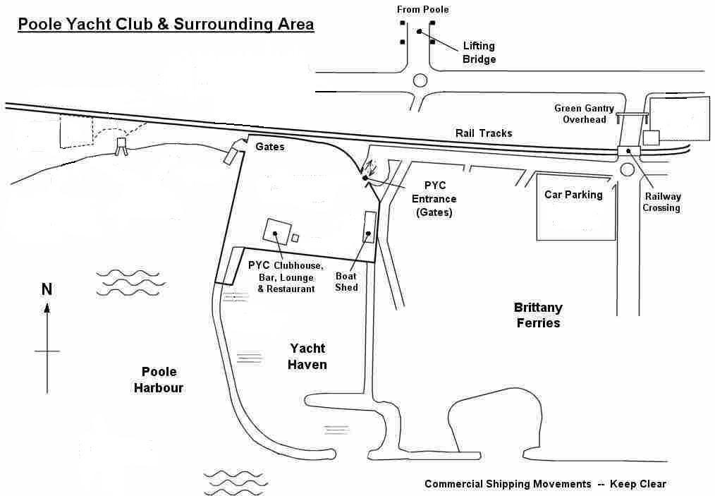

Addendum B – Race Area

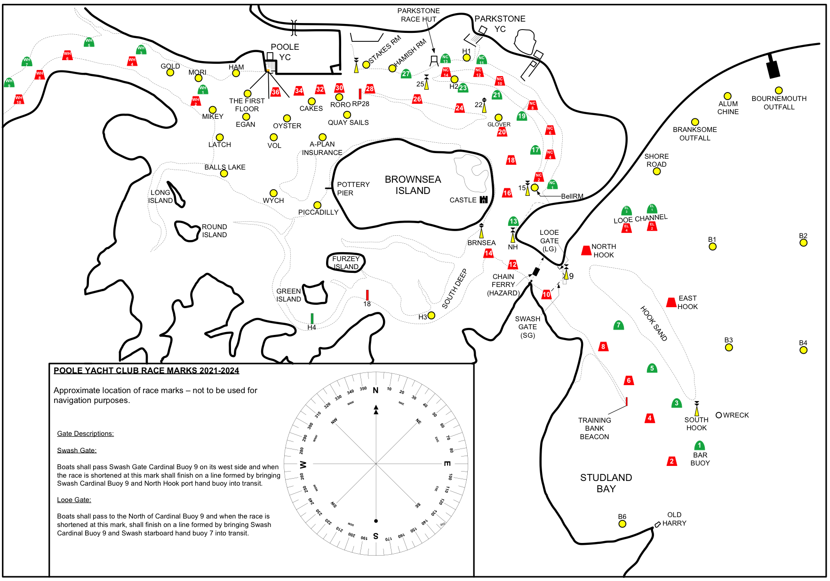

**Expected Race Area**