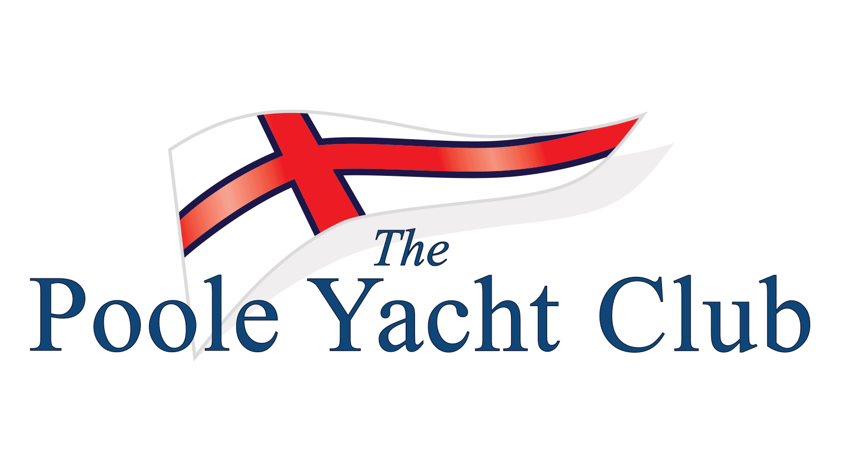

WANT TO TRY SAILING A DAYBOAT?

POOLE YACHT CLUB MEMBERS ARE HOLDING 'TRY A DAYBOAT’ DAYS ON:

Sundays 12th MAY and 9th June 2024
from 11 am.

Dayboat sailors will be on hand to give you a chnce to experience Dayboat sailing. NO WET FEET! Just step off the pontoon into a Dayboat and enjoy a sail in Poole harbour.

For more information or to let us know you are coming contact the class captain, Steve Wilson, 07986 905940 or stevetwilson675@gmail.com

Can’t make those dates? Contact us anyway and we will see what we can sort out.

Poole Yacht Club entrance is within the Poole port area. Postcode: BH15 4AQ.
Club website: pooleyc.co.uk

